Bangladesh Medical Association (BMA)
List of Life Member-209
44. BMA Narayanganj Branch

Sl No | Voter No | Voter Details
1 | Voter No  LM-4400001  No Image | DR. ABDUR ROUF  F/Name:  M/Name:  BM & DC Reg. No:  NID:  Cell:  Address: 117, N.S. Road, Kazipara  Narayangonj  Blood Group:  E X P I R E D
2 | Voter No  LM-4400002  No Image | DR. KHAN MOHAMMED MASIUR RAHMAN  F/Name:  M/Name:  BM & DC Reg. No:  NID:  Cell:  Address: 52, Shah Suja Road  Narayangonj  Blood Group:
3 | Voter No  LM-4400003 | DR. LAILA F.A BANU  F/Name:  M/Name:  BM & DC Reg. No:  NID:  Cell:  Address: 15, NS Road  Narayangonj  Blood Group:
4 | Voter No  LM-4400004 | DR. M. NURUL ISLAM  F/Name: Alhaj Sona Mia  M/Name:  BM & DC Reg. No:  NID:  Cell:  Address: 3, DIT Market (1st Floor)  Narayangonj  Blood Group:
5 | Voter No  LM-4400005 | DR. ALHAJ MD. SHAH NEWAZ CHOWDHURY  F/Name: Late Chowdhury M.a. Hamid  M/Name:  BM & DC Reg. No:  NID:  Cell:  Address: Shah Newaz Chamber  143, B.B. Road  Narayangonj.  Blood Group:
6 | Voter No  LM-4400006  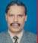 | DR. TIM NURUNNABI  F/Name: Late Nazmul Haque Khandaker  M/Name:  BM & DC Reg. No:  NID:  Cell:  Address: 4, D I T  Narayangonj  Blood Group:
7 | Voter No  LM-4400007  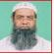 | DR. MD. ABDUL AWAL  F/Name:  M/Name:  BM & DC Reg. No:  NID:  Cell:  Address: 137, B. B. Road  Narayangonj  Blood Group:
8 | Voter No  LM-4400008  No Image | DR. MD. SHAFIQUL ISLAM  F/Name:  M/Name:  BM & DC Reg. No:  NID:  Cell:  Address: Nur Pharmacy  Hazi Younus Super Market  Pagla  Narayangonj  Blood Group:
9 | Voter No  LM-4400009  No Image | DR. A B M GOLAM FARUQUE  F/Name:  M/Name:  BM & DC Reg. No:  NID:  Cell:  Address: TRANSFERED to BMA Dhaka City  LM-  Blood Group:  TRANSFERED to BMA Dhaka City  LM-1405543
10 | Voter No  LM-4400010  No Image | DR. SELINA AKHTER IVY  F/Name:  M/Name:  BM & DC Reg. No:  NID:  Cell:  Address: 157, West Deobhog,  Narayangonj  Blood Group:
11 | Voter No  LM-4400011  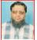 | DR. SHARIF MOHAMMAD MOSADDEQUE  F/Name:  M/Name:  BM & DC Reg. No:  NID:  Cell:  Address: West Deobhog  Banglabazar  Narayangonj  Blood Group:
12 | Voter No  LM-4400012  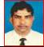 | DR. MD. TAYOB ALI  F/Name:  M/Name:  BM & DC Reg. No:  NID:  Cell:  Address: Asst. Reg. ENT  200 Beded Hospital  Narayangonj  Blood Group:
13 | Voter No  LM-4400013  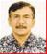 | DR. SANJIB KUMAR GHOSH  F/Name:  M/Name:  BM & DC Reg. No:  NID:  Cell:  Address: Consultant  200 Beded Hospital  Narayangonj  Blood Group:
14 | Voter No  LM-4400014  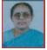 | DR. MAYA SAHA  F/Name:  M/Name:  BM & DC Reg. No:  NID:  Cell:  Address: Consultant, General Hospital,  Narayangonj.  Blood Group:  E X P I R E D
15 | Voter No  LM-4400015  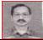 | DR. SUKHAMOY SAHA  F/Name:  M/Name:  BM & DC Reg. No:  NID:  Cell:  Address: EMO, 200 Beded Hospital  Narayangonj  Blood Group:
16 | Voter No  LM-4400016  No Image | DR. A. S. M. AKRAMUL ISLAM  F/Name:  M/Name:  BM & DC Reg. No:  NID:  Cell:  Address: 233/6, B. B. Road  Press Club Building  Narayangonj  Blood Group:
17 | Voter No  LM-4400017  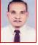 | DR. MD. MOFIZUL ISLAM  F/Name: Md. Asfor Ali  M/Name:  BM & DC Reg. No:  NID:  Cell:  Address: Kimty Drug House  106, LNA Road  Narayangonj  Blood Group:
18 | Voter No  LM-4400018  No Image | DR. MD. ZAINUL ABEDIN  F/Name: Late Alhaz Md. Ismail Mallik  M/Name:  BM & DC Reg. No:  NID:  Cell:  Address: 3, DIT. Narayangonj.  Blood Group:  E X P I R E D
19 | Voter No  LM-4400019  No Image | DR. MIRZA A. SOBHAN  F/Name: Mirza Moniruddin  M/Name:  BM & DC Reg. No:  NID:  Cell:  Address: Mirza Bari, 138, N.S Road  Narayangonj  Blood Group:  E X P I R E D
20 | Voter No  LM-4400020  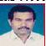 | DR. MAZOR (RTD.) AZIZ  F/Name: Khan Sirajul Islam  M/Name:  BM & DC Reg. No:  NID:  Cell:  Address: 3, DIT Market  Narayangonj  Blood Group:
21 | Voter No  LM-4400021  No Image | DR. MD. MOSTAFIZUR RAHMAN  F/Name: Late Md. Esmail Miah  M/Name:  BM & DC Reg. No:  NID:  Cell:  Address: Mostafiz Centre  Fatullah  Narayangonj  Blood Group:
22 | Voter No  LM-4400022  No Image | DR. MD. MOZHARUL HOQUE  F/Name: Late Md. Nurul Hoque  M/Name:  BM & DC Reg. No:  NID:  Cell:  Address: Syed Pharmcay  Post Office Road, Fatullah  Narayangonj  Blood Group:
23 | Voter No  LM-4400023 | DR. CAPT. (RTD.) MD. ABUL FATAN  F/Name: Late Torab Ali Prodan  M/Name:  BM & DC Reg. No:  NID:  Cell:  Address: 117, B. B. Road  Narayangonj  Blood Group:
24 | Voter No  LM-4400024 | DR. S. M. SHAHNEWAZ (NOMAN)  F/Name: SM Mahe Alam  M/Name:  BM & DC Reg. No:  NID:  Cell:  Address: 4, DIT Market  Narayangonj  Blood Group:
25 | Voter No  LM-4400025  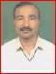 | DR. MD. HAFIZUR RAHMAN  F/Name: Late Md. Azizur Rahman Sarkar  M/Name:  BM & DC Reg. No:  NID:  Cell:  Address: Deshbondhu Eye Chikitshaloy  2/20, DIT Market  Narayangonj  Blood Group:
26 | Voter No  LM-4400026 | DR. MD. ABUL HOSSAIN MIAH  F/Name: Alhaj Ahmed Ali  M/Name:  BM & DC Reg. No:  NID:  Cell:  Address: 33, Mohim Ganguli road  Narayangonj  Blood Group:
27 | Voter No  LM-4400027 | DR. DILIP KUMAR DAS  F/Name: Late Rabindronath Das  M/Name:  BM & DC Reg. No:  NID:  Cell:  Address: 117, B. B. Road  Narayangonj  Blood Group:
28 | Voter No  LM-4400028  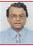 | DR. MD. MOFAKHKHARUL BARI  F/Name: Late Hafez Moulana A.K.  M/Name:  BM & DC Reg. No:  NID:  Cell:  Address: Moumajid Ahmed  85, N. S. Road  Narayangonj  Blood Group:
29 | Voter No  LM-4400029  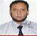 | DR. ABDUL HANNAN  F/Name: Late Munshi Lal Mia  M/Name:  BM & DC Reg. No:  NID:  Cell:  Address: 30, H. K. Banarjee Road  Narayangonj  Blood Group:
30 | Voter No  LM-4400030  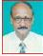 | DR. SHARFUDDIN AHMED  F/Name: Late Md. Hossain Uddin  M/Name:  BM & DC Reg. No:  NID:  Cell:  Address: 169, B. B, Road  Narayangonj  Blood Group:  E X P I R E D
31 | Voter No  LM-4400031  No Image | DR. MOHAMMED A. AHSAN  F/Name:  M/Name:  BM & DC Reg. No:  NID:  Cell:  Address: Transfered to BMA Dhaka City  LM-2035  Blood Group:  TRANSFERED to BMA Dhaka City  LM-1405543
32 | Voter No  LM-4400032  No Image | DR. S.M. EAR-E-MAHABUB  F/Name:  M/Name:  BM & DC Reg. No:  NID:  Cell:  Address: 114, Nabiganj  Narayangonj  Blood Group:
33 | Voter No  LM-4400033  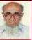 | DR. MD. RAFIQUL ISLAM  F/Name: Moulovi Nur Mohammad  M/Name:  BM & DC Reg. No:  NID:  Cell:  Address: 3, DIT  Narayangonj  Blood Group:
34 | Voter No  LM-4400034 | DR. ASHIS KUMAR DEY  F/Name: Sujit Kumar Day  M/Name:  BM & DC Reg. No:  NID:  Cell:  Address: Aman Bhaban  119, B.B. Road  Narayangonj  Blood Group:
35 | Voter No  LM-4400035  No Image | DR. MOSHIUR RAHMAN MOLLICK  F/Name: Late Gulzar Ali Mollick  M/Name:  BM & DC Reg. No:  NID:  Cell:  Address: 96, North Chashara  Narayangonj  Blood Group:
36 | Voter No  LM-4400036  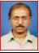 | DR. MONJUR AHMED  F/Name: Md. Shawayeb Ali  M/Name:  BM & DC Reg. No:  NID:  Cell:  Address: Registrar Surgery  200 Beded Hospital  Narayangonj  Blood Group:
37 | Voter No  LM-4400037  No Image | DR. M I MD. NASIM SOBHANI KHONDKER  F/Name: Golam Robbani Khondker  M/Name:  BM & DC Reg. No:  NID:  Cell:  Address: Consultant  389, Lalmatia, Block – E, Dhaka  Blood Group:
38 | Voter No  LM-4400038  No Image | DR. MD. BADIUL ALAM AKHAND  F/Name:  M/Name:  BM & DC Reg. No:  NID:  Cell:  Address: Transfered to BMA Narsindi Br.  LM-22  Blood Group:  TRANSFERED to BMA Dhaka City  LM-1405543
39 | Voter No  LM-4400039  No Image | DR. AHMED FAISAL HASAN  F/Name: Prof Alhaz Shamsuddin Ahmed  M/Name:  BM & DC Reg. No:  NID:  Cell:  Address: Ex-M. O. (Eye)  200 Beded Hospital  Narayangonj  Blood Group:
40 | Voter No  LM-4400040  No Image | DR. MD. RABIUL HOSSAIN  F/Name: Late Md. Tazal Islam  M/Name:  BM & DC Reg. No:  NID:  Cell:  Address: Ex-Consultant  200 Beded Hospital  Narayangonj  Blood Group:
41 | Voter No  LM-4400041  No Image | DR. FARUQUE AHMED  F/Name: Rakib Uddin Ahmed  M/Name:  BM & DC Reg. No:  NID:  Cell:  Address: Desh Pharmacy  B.B. Road  Narayangonj  Blood Group:
42 | Voter No  LM-4400042  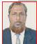 | DR. KAZI MD. ABDUS SALAM  F/Name: Kazi Md. Israil  M/Name:  BM & DC Reg. No:  NID:  Cell:  Address: 172, B.B. Road  Narayangonj  Blood Group:
43 | Voter No  LM-4400043  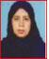 | DR. NAZMA AKHTER BANU  F/Name: Abdul Bari Fakir  M/Name:  BM & DC Reg. No:  NID:  Cell:  Address: Registered (Paed)  200 Beded Hospital  Narayangonj  Blood Group:
44 | Voter No  LM-4400044  No Image | DR. MD. AZIZAR RHAMAN  F/Name:  M/Name:  BM & DC Reg. No:  NID:  Cell:  Address: Transfered to BMA Dinajpur  BranchLM-112  Blood Group:  TRANSFERED to BMA Dhaka City  LM-1405543
45 | Voter No  LM-4400045 | DR. ANIL KUMAR BASAK  F/Name: Late Babu Lal Basak  M/Name:  BM & DC Reg. No:  NID:  Cell:  Address: Mediplus  President Road  Narayangonj  Blood Group:
46 | Voter No  LM-4400046  No Image | DR. KUTUB UDDIN CHOWDHURY  F/Name: Moulovi Md. Lutfur Rahman  M/Name:  BM & DC Reg. No:  NID:  Cell:  Address: Asst. Reg.  200 Beded Hospital  Narayangonj  Blood Group:
47 | Voter No  LM-4400047  No Image | DR. MOHAMMAD BODRUDDOZA  F/Name:  M/Name:  BM & DC Reg. No:  NID:  Cell:  Address: TRANSFERED to BMA Khulna  Branch LM-2900247  Blood Group:  TRANSFERED to BMA Dhaka City  LM-1405543
48 | Voter No  LM-4400048  No Image | DR. MD. ABDUL AWAL MIAH  F/Name: Alhaj Md. Abdul Maleque Miah  M/Name:  BM & DC Reg. No:  NID:  Cell:  Address: Ex-Emo, 200 Beded Hospital. Narayanganj.  Blood Group:
49 | Voter No  LM-4400049  No Image | DR. JYOTI MADHAB BANIK  F/Name: Late Bindu Madhab Banik  M/Name:  BM & DC Reg. No:  NID:  Cell:  Address: EMO, 200 Beded Hospital  Narayangonj  Blood Group:
50 | Voter No  LM-4400050  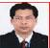 | DR. K. M. ASHRAF ALI  F/Name: Md. Jalal Uddin Ahmed  M/Name:  BM & DC Reg. No:  NID:  Cell:  Address: North Chashara  Narayangonj  Blood Group:
51 | Voter No  LM-4400051  No Image | DR. DIPA ISLAM  F/Name: Late Ruhini Das  M/Name:  BM & DC Reg. No:  NID:  Cell:  Address: 117/3, Don Chamber  Narayangonj  Blood Group:
52 | Voter No  LM-4400052 | DR. SAYEED AHMED SIDDKY  F/Name: Mr. Quamruddin Ahmed Siddiqy  M/Name:  BM & DC Reg. No:  NID:  Cell:  Address: 72, Sat Masjid Road  Dhanmondi  Dhaka  Blood Group:
53 | Voter No  LM-4400053  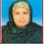 | DR. FATEMA SHIRIN  F/Name: Late Md. Gazi Abdullah  M/Name:  BM & DC Reg. No:  NID:  Cell:  Address: 117/5 West Deobhog  Beparipara  Narayangonj  Blood Group:
54 | Voter No  LM-4400054  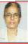 | DR. CHINU RANI ROY  F/Name: Late Prasanna Kr. Roy  M/Name:  BM & DC Reg. No:  NID:  Cell:  Address: Sr. Consultant  200 Beded Hospital  Narayangonj  Blood Group:
55 | Voter No  LM-4400055  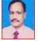 | DR. SYED HAMEDUL HAQUE  F/Name: Syed Zahedul Hoque  M/Name:  BM & DC Reg. No:  NID:  Cell:  Address: Modina Optical  2/9, DIT Market  Narayangonj  Blood Group:
56 | Voter No  LM-4400056 | DR. R AHSAN  F/Name: Md. Mozammel Hoque  M/Name:  BM & DC Reg. No:  NID:  Cell:  Address: 78/3 New Chashara, Jamtala  Narayangonj  Blood Group:
57 | Voter No  LM-4400057 | DR. SHAMINA JAHAN  F/Name: Md. Abdul Aziz  M/Name:  BM & DC Reg. No:  NID:  Cell:  Address: 78/3 New Chashara,Jamtala  Narayangonj  Blood Group:
58 | Voter No  LM-4400058 | DR. SALEHA AKTER  F/Name: Mr. Alhaj Mohammed Ali  M/Name:  BM & DC Reg. No:  NID:  Cell:  Address: Shahnewaz Chamber  143. B. B. Road  Narayangonj  Blood Group:
59 | Voter No  LM-4400059 | DR. PRADIP KUMAR DAS  F/Name: Late Bisweswar Das  M/Name:  BM & DC Reg. No:  NID:  Cell:  Address: 54, B. B. Road  Narayangonj  Blood Group:
60 | Voter No  LM-4400060  No Image | DR. MD. NAZRUL ISLAM  F/Name: Md. Abdus Shobhan  M/Name:  BM & DC Reg. No:  NID:  Cell:  Address: Sharif Clinic  145, B. B. Road, Narayanganj.  Blood Group:
61 | Voter No  LM-4400061  No Image | DR. MD. SHAMSUL KARIM  F/Name:  M/Name:  BM & DC Reg. No:  NID:  Cell:  Address: Asstt. Prof. (Psych) Comilla Medical College,Comilla  Blood Group:  TRANSFERED to BMA Dhaka City  LM-1405543
62 | Voter No  LM-4400062 | DR. MD. AFTAB UDDIN  F/Name: Alhaj Almas Ali  M/Name:  BM & DC Reg. No:  NID:  Cell:  Address: Bondor THC  Narayangonj  Blood Group:
63 | Voter No  LM-4400063  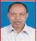 | DR. MD. NURUL ISLAM  F/Name: Late Md. Belal Uddin Mian  M/Name:  BM & DC Reg. No:  NID:  Cell:  Address: Jr. Consultant  General Hospital  Narayangonj  Blood Group:
64 | Voter No  LM-4400064  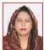 | DR. PARVEEN AHMED  F/Name: Affazuddin Ahmed  M/Name:  BM & DC Reg. No:  NID:  Cell:  Address: Jr. Consultant  General Hospital  Narayangonj  Blood Group:
65 | Voter No  LM-4400065  No Image | DR. MD. GULAM KIBRIA  F/Name:  M/Name:  BM & DC Reg. No:  NID:  Cell:  Address: Transfered to BMA Norshingdi  LM-4500012 Next Transfered to  Dhaka City LM-1402847  Blood Group:  TRANSFERED to BMA Dhaka City  LM-1405543
66 | Voter No  LM-4400066  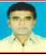 | DR. MD. GOLAM MOSTAFA  F/Name: Md. Akkas Ali  M/Name:  BM & DC Reg. No:  NID:  Cell:  Address: Araihazar THC  Narayangonj  Blood Group:
67 | Voter No  LM-4400067  No Image | DR. MD. FIROZ AHMED KHAN  F/Name: Md. Fazlul Karim Khan  M/Name:  BM & DC Reg. No:  NID:  Cell:  Address: Medical Specialist  THC, Araihazar  Narayangonj  Blood Group:
68 | Voter No  LM-4400068  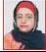 | DR. CHEMANARA BEGUM  F/Name: Md. Siddiqur Rahman  M/Name:  BM & DC Reg. No:  NID:  Cell:  Address: 97/2 DP Road, 2, Baburail  Narayangonj  Blood Group:
69 | Voter No  LM-4400069  No Image | DR. BAKHTIARUZZAMAN  F/Name: Late Moniruzzaman Khan  M/Name:  BM & DC Reg. No:  NID:  Cell:  Address: Fatullah, Narayangonj  Blood Group:  E X P I R E D
70 | Voter No  LM-4400070 | DR. G. M. FARID  F/Name: Abul Bahar Gazi  M/Name:  BM & DC Reg. No:  NID:  Cell:  Address: Anaesthetist  General Hospital  Narayangonj  Blood Group:
71 | Voter No  LM-4400071  No Image | DR. MEHER PARVEEN  F/Name: Late Abdul Mannan  M/Name:  BM & DC Reg. No:  NID:  Cell:  Address: 242/3/A, Shenpara, Parbota  Mirpur-10, Dhaka.  Blood Group:
72 | Voter No  LM-4400072  No Image | DR. SUBHEN KUMAR PODDAR  F/Name: Sarojendra Nath Poddar  M/Name:  BM & DC Reg. No:  NID:  Cell:  Address: Holly Clinic  9, B. B. Road,  Narayangonj  Blood Group:
73 | Voter No  LM-4400073  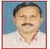 | DR. RAJA DEVA SANKAR MONDAL  F/Name: Late Rasa Raj Mondal  M/Name:  BM & DC Reg. No:  NID:  Cell:  Address: Nani Saha, 31, DN Road  Narayangonj  Blood Group:
74 | Voter No  LM-4400074  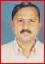 | DR. SHAMSUDDIN  F/Name: Moh. Mofizuddin  M/Name:  BM & DC Reg. No:  NID:  Cell:  Address: Emon Medical Store  42, Serajdowla Road  Narayangonj  Blood Group:
75 | Voter No  LM-4400075 | DR. SYEDA MISHKAD JAHAN  F/Name: Syeda Rashid  M/Name:  BM & DC Reg. No:  NID:  Cell:  Address: Jr. Consultant  200 Beded Hospital  Narayangonj  Blood Group:
76 | Voter No  LM-4400076  No Image | DR. TOFAYEL AHMED  F/Name: Naim Uddin Miah  M/Name:  BM & DC Reg. No:  NID:  Cell:  Address: Consultant, Eye  200 Beded Hospital  Narayangonj  Blood Group:
77 | Voter No  LM-4400077  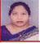 | DR. SHAHEEN AKHTER  F/Name: Mohammad Shamsuddin  M/Name:  BM & DC Reg. No:  NID:  Cell:  Address: M. O. SOPD  200 Beded Hospital  Narayangonj  Blood Group:
78 | Voter No  LM-4400078 | DR. SK. MOHD. ABU JAFAR  F/Name:  M/Name:  BM & DC Reg. No:  NID:  Cell:  Address: Popular Diagnostic Centre  B. B. Road  Narayangonj  Blood Group:
79 | Voter No  LM-4400079  No Image | DR. NUR KUTUBUL ALAM  F/Name:  M/Name:  BM & DC Reg. No:  NID:  Cell:  Address: Senior Consultant  200 Beded Hospital  Narayangonj  Blood Group:  TRANSFERED to BMA Dhaka City  LM-1405543
80 | Voter No  LM-4400080  No Image | DR. HAMIDA BEGUM  F/Name:  M/Name:  BM & DC Reg. No:  NID:  Cell:  Address: Narayangonj  Blood Group:  TRANSFERED to BMA Dhaka City  LM-1405543
81 | Voter No  LM-4400081  No Image | DR. A.B.M. MONIR UDDIN  F/Name:  M/Name:  BM & DC Reg. No:  NID:  Cell:  Address: Tranfered to Dhaka City  LM-1401652.  Blood Group:  TRANSFERED to BMA Dhaka City  LM-1405543
82 | Voter No  LM-4400082  No Image | DR. ABM. GOLAM RABBANI  F/Name:  M/Name:  BM & DC Reg. No:  NID:  Cell:  Address: 85, N.S. Road, Narayanganj.  Blood Group:
83 | Voter No  LM-4400083  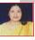 | DR. LAILA PARVIN (MADHABI)  F/Name:  M/Name:  BM & DC Reg. No:  NID:  Cell:  Address: Don Chamber  Narayangonj  Blood Group:
84 | Voter No  LM-4400084  No Image | DR. M. A. AWAL  F/Name:  M/Name:  BM & DC Reg. No:  NID:  Cell:  Address: M. O. Naraynganj Jail  Narayanganj  Blood Group:
85 | Voter No  LM-4400085  No Image | DR. GOLAM KIBRIA CHOWDHURY  F/Name:  M/Name:  BM & DC Reg. No:  NID:  Cell:  Address: „  Blood Group:
86 | Voter No  LM-4400086  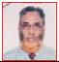 | DR. MALIK KHAIRUL ANAM  F/Name:  M/Name:  BM & DC Reg. No:  NID:  Cell:  Address: Consultant (Eye),  General Hospital,  Narayanganj  Blood Group:
87 | Voter No  LM-4400086  No Image | DR. MALIK KHAIRUL ANAM  F/Name:  M/Name:  BM & DC Reg. No:  NID:  Cell:  Address: Consultant (Eye),  General Hospital,  Narayangonj  Blood Group:  TRANSFERED to BMA Dhaka City  LM-1405543
88 | Voter No  LM-4400087  No Image | DR. AKLIMA AKHTER BANU  F/Name:  M/Name:  BM & DC Reg. No:  NID:  Cell:  Address: 4, DIT  Narayanganj  Blood Group:
89 | Voter No  LM-4400088  No Image | DR. MUZIBUR RAHMAN  F/Name:  M/Name:  BM & DC Reg. No:  NID:  Cell:  Address: 4, DIT  Sadar Hospital  Narayanganj  Blood Group:
90 | Voter No  LM-4400089 | DR. MD. SHAFIQUL ISLAM  F/Name:  M/Name:  BM & DC Reg. No:  NID:  Cell:  Address: Registrar (Paed)  200 Beded Hospital  Narayanganj  Blood Group:
91 | Voter No  LM-4400090  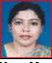 | DR. KAMRU NAHAR  F/Name:  M/Name:  BM & DC Reg. No:  NID:  Cell:  Address: 104, Naypara Road  Paikpara  Narayanganj  Blood Group:
92 | Voter No  LM-4400091  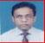 | DR. MD. SHAMSUR RAHMAN  F/Name:  M/Name:  BM & DC Reg. No:  NID:  Cell:  Address: M.O. Civil Surgeon Office  Narayanganj  Blood Group:
93 | Voter No  LM-4400092 | DR. ALI ASHRAF KHAN  F/Name: Md. Abdul Latif  M/Name:  BM & DC Reg. No:  NID:  Cell:  Address: Vill-Dapa Idrakpur  Fatullah  Narayanganj  Blood Group:
94 | Voter No  LM-4400093  No Image | DR. MD. JAHANGIR ALAM  F/Name:  M/Name:  BM & DC Reg. No:  NID:  Cell:  Address: 46/6 B New Chashara, Jamtola  Narayangonj.  Blood Group:
95 | Voter No  LM-4400094  No Image | DR. A.K.M. SHAFIQUL ALAM  F/Name:  M/Name:  BM & DC Reg. No:  NID:  Cell:  Address: 121, Khanpur Main Road  Narayangonj.  Blood Group:
96 | Voter No  LM-4400095  No Image | DR. SHAMAL CHANDRA DEBNATH  F/Name:  M/Name:  BM & DC Reg. No:  NID:  Cell:  Address: 23/6, Prominent Housing  Road-3, P C Culture, Mohammadpur  Dhaka.  Blood Group:
97 | Voter No  LM-4400096  No Image | DR. MD. MATIUL HOQUE  F/Name:  M/Name:  BM & DC Reg. No:  NID:  Cell:  Address: 68, sonabibi Road, Sonakanda  Narayangonj.  Blood Group:
98 | Voter No  LM-4400097  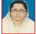 | DR. AYESHA AKHTER  F/Name:  M/Name:  BM & DC Reg. No:  NID:  Cell:  Address: Munshi Villa  Hajee Gonj Narayangonj.  Blood Group:
99 | Voter No  LM-4400098  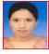 | DR. ANIKA NAWAR SADIA  F/Name:  M/Name:  BM & DC Reg. No:  NID:  Cell:  Address: 232, West Deovogh  Narayangonj.  Blood Group:
100 | Voter No  LM-4400099  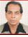 | DR. MD. MASUDUL HUQ SIRAJEE  F/Name:  M/Name:  BM & DC Reg. No:  NID:  Cell:  Address: Apartment # B 3, House No-63  Road No.3, Gulshan-1  Dhaka-1212.  Blood Group:
101 | Voter No  LM-4400100  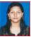 | DR. SHAILA SHARMIN SHAHNEWAZ  F/Name: Alhaj Dr.md. Shahnewaz Chowdhury  M/Name:  BM & DC Reg. No:  NID:  Cell:  Address: Shahnewaz Chamber  143, B.B. Road  Narayangonj.  Blood Group:
102 | Voter No  LM-4400101  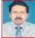 | DR. ATIKUZZAMAN SOHEL  F/Name:  M/Name:  BM & DC Reg. No:  NID:  Cell:  Address: 12, D.P. Road, 2 No. Baburail  Narayangonj.  Blood Group:
103 | Voter No  LM-4400102  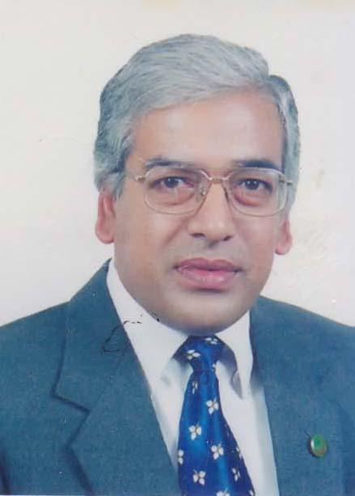 | DR. GOUR SUNDAR SAHA  F/Name: Late. Thakur Das Saha  M/Name: Mrs. Jai Mati Saha  BM & DC Reg. No: 44630  NID: 6725804367839  Cell: 01912527627  Address: 121, Chasara, 9D, Baily Tower, Narayangonj.  Blood Group: B+
104 | Voter No  LM-4400103  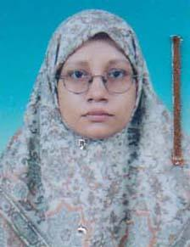 | DR. ZAKIA PARVIN  F/Name: Late. Dr. M.a Wahhab  M/Name: Mrs. Rezia Khatun  BM & DC Reg. No: 22857  NID: 6725804365324  Cell: 01713011164  Address: House No: 46, Holding No: 27, H.K. Banarjee Road, Amlapara, Narayangonj.  Blood Group: B+
105 | Voter No  LM-4400104  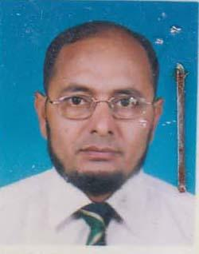 | DR. MD. TAFAZZAL HOSSAIN  F/Name: Late Md. Abdus Sattar  M/Name: Mrs. Afia Khatoon  BM & DC Reg. No: 24111  NID: 1918149718515  Cell: 01715901755  Address: Lutfa Tower (1st Floor), 230/1-BB. Road, Chashara, Narayangonj.  Blood Group: A+
106 | Voter No  LM-4400105  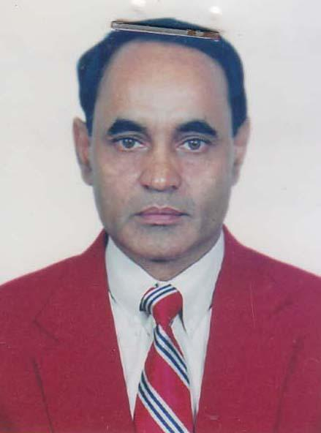 | MD. MAHMUDUL ALAM TALUKDER  F/Name: Late Abdul Mozid Talukder  M/Name: Ms. Saleha Begum  BM & DC Reg. No: 9557  NID: 6725803907159  Cell: 01819226927  Address: Doctors Quarter, 200 Bed Hospital, Naryangonj.  Blood Group: O+
107 | Voter No  LM-4400106  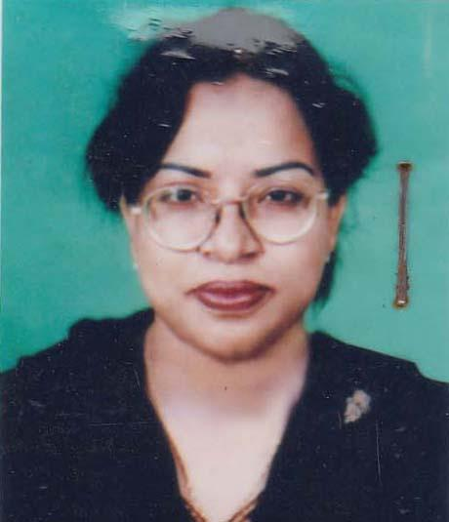 | DR. SHARMIN SULTANA  F/Name: Md. Abdul Hakim  M/Name: Mrs. Z.h Begum  BM & DC Reg. No: 29373  NID: 6725803407144  Cell: 01711236047  Address: Doctors Quarter, 200 Bedded Hospital Khanpur, Narayanganjj.  Blood Group: B+
108 | Voter No  LM-4400107  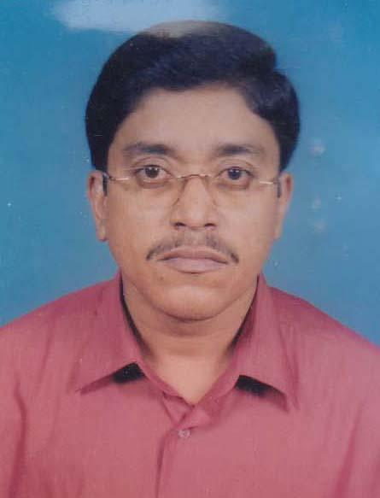 | DR. NASIR AHMED  F/Name: Md. Ahsan Ullah  M/Name: Mrs. Noorjahan  BM & DC Reg. No: 23180  NID: 6725806398187  Cell: 01715882730  Address: 171, Deobhog, Pucca Road, Narayngonj.  Blood Group: A+
109 | Voter No  LM-4400108  No Image | DR. NILUFOR AKHTER  F/Name:  M/Name:  BM & DC Reg. No:  NID:  Cell:  Address: 180, Deobhog Pucca Road,  Narayangonj  Blood Group: A+
110 | Voter No  LM-4400109  No Image | DR. MIR NUR-E-NAZMA  F/Name:  M/Name:  BM & DC Reg. No:  NID:  Cell:  Address: 49 K.C Nag Road, Amlapara,  Narayangonj.  Blood Group:
111 | Voter No  LM-4400110  No Image | DR. MD. AMINUR RAHMAN  F/Name:  M/Name:  BM & DC Reg. No:  NID:  Cell:  Address: Junior Consultant (Anaestheciology.)  200 Beded Hospital  Narayangonj.  Blood Group:
112 | Voter No  LM-4400111  No Image | DR. ZAHANGIR ALAM  F/Name:  M/Name:  BM & DC Reg. No:  NID:  Cell:  Address: Doctors Hostel, 200 Bed Hospital  Narayangonj.  Blood Group:
113 | Voter No  LM-4400112  No Image | DR. MOHAMMAD NIZAM ALI  F/Name:  M/Name:  BM & DC Reg. No:  NID:  Cell:  Address: 136/1 Nalua Road  Narayangonj.  Blood Group:
114 | Voter No  LM-4400113  No Image | DR. MUNIRUZZAMAN SALIM  F/Name:  M/Name:  BM & DC Reg. No:  NID:  Cell:  Address: 12 D.P Road, 2 No, Baburail  Narayangonj.  Blood Group:
115 | Voter No  LM-4400114  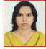 | DR. ELIZA FAHRIA  F/Name: Md. Moklesur Rahman  M/Name: Farhad Akhter Banu  BM & DC Reg. No: 35284  NID:  Cell:  Address: 12 D.P Road, 2 No, Baburail,  Narayangonj.  Blood Group:
116 | Voter No  LM-4400115  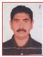 | DR. DEBASHISH SAHA  F/Name: Ranjit Kumar Saha  M/Name: Sandha Rani Saha  BM & DC Reg. No: A-36206  NID:  Cell:  Address: Medi Life Diagnostic Centre  Green Super Market, 2 No. B B Road  Narayangonj.  Blood Group: O+
117 | Voter No  LM-4400116 | DR. SAYED AHAMMED  F/Name: Nasir Ahammed  M/Name: Suraiya Nasir  BM & DC Reg. No: 33782  NID: 6725809053881  Cell: 01711264639  Address: 65/2, B.K. Road, Naryangonj.  Blood Group: O+
118 | Voter No  LM-4400117  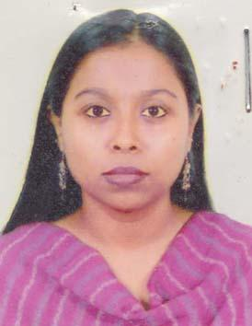 | DR. JEASMIN SULTANA  F/Name: Jashim Uddin Ahammed  M/Name: Ayesha Akhter  BM & DC Reg. No: 42782  NID: 6725805740090  Cell: 01713364591  Address: Islam Medical Centre, 3/9, D.I.T Market Naraynganj.  Blood Group: B+
119 | Voter No  LM-4400118  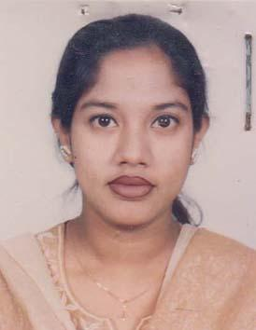 | DR. NAZMA BEGUM  F/Name: Late. Alhaz Golam Rahman  M/Name: Alhaz Fulzan Begum  BM & DC Reg. No: 32187  NID: 6725802730481  Cell: 01819154187  Address: 38/A Isha Khan Road, Killarpur, Naryanganj.  Blood Group: B+
120 | Voter No  LM-4400119  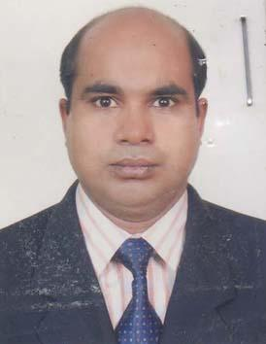 | DR. A.K. SHAFI UDDIN AHMED  F/Name: Muhammad Abdul Khaleque  M/Name: Khodeza Akter  BM & DC Reg. No: 35734  NID:  Cell: 01716827751  Address: Khodeza Mansion, 36/2, Sher e Bangla Road, Masdair, Narayangonj.  Blood Group: A+
121 | Voter No  LM-4400120  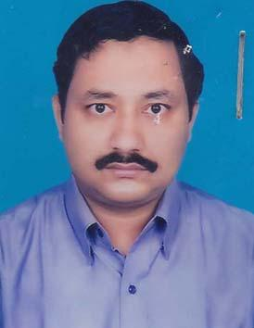 | DR. MD. MAKBUL HOSSAIN BHUIYAN  F/Name: Md. Afsar Uddin Bhuiyan  M/Name: Fatema Khatun  BM & DC Reg. No: 22887  NID: 6725803904518  Cell: 01911570373  Address: 117/2, Khanpur Main Road, Danchamber, Narayngonj.  Blood Group: B+
122 | Voter No  LM-4400121  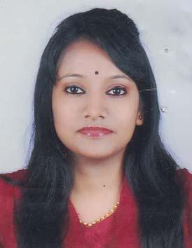 | DR. TAMANNA JAHAN NAVY  F/Name: Md. Golam Mostafa  M/Name: Tahmina Mostafa Rotna  BM & DC Reg. No: 56007  NID: 1916765152918  Cell: 01670974759  Address: Room No: 206, Intern Hostel (Ladies) Comilla Medical College Hospital, Comilla.  Blood Group: A+
123 | Voter No  LM-4400122  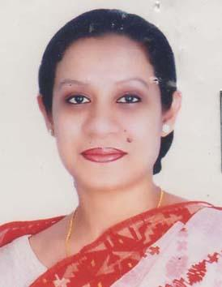 | DR. SAYMA AFROZ  F/Name: Mohammad Asaduzzaman (advocate)  M/Name: Sharifa Zaman  BM & DC Reg. No: 44445  NID: 6710231549329  Cell: 01727699370  Address: Eastern Pair, 88 Shantinagor, Dhaka.  Blood Group: A+
124 | Voter No  LM-4400123 | DR. ATAUR RAHMAN  F/Name: Late. Muhammad Mohiuddin  M/Name: Rehena Begum  BM & DC Reg. No: 42164  NID:  Cell: 01818723536  Address: Medical Officer, UHC, Araihazar, Narayanganj  Blood Group: O+  E X P I R E D
125 | Voter No  LM-4400124  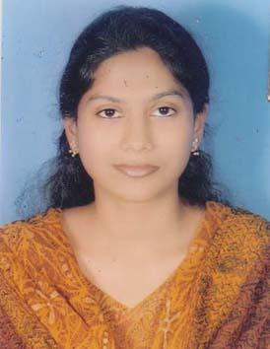 | DR. SCLERA SHAHNEWAZ  F/Name: Dr. Md. Shahnewaz Chowdhury  M/Name: Afroza Shahenewaz  BM & DC Reg. No: 70488  NID: 6725805754405  Cell: 01922110703  Address: Shahanewaz Chamber, 143, B.B. Road, Naryangonj.  Blood Group: O+
126 | Voter No  LM-4400125 | DR. MD. GOLAM MUSTAFA  F/Name: Md. Abdul Hossain  M/Name: Mrs. Rabeya Begum  BM & DC Reg. No: 18761  NID: 6112029490679  Cell: 01711961795  Address: Maa O Shishu Kallan Kendra  Narayangonj.  Blood Group: O+
127 | Voter No  LM-4400126  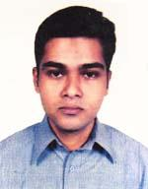 | DR. S. M. SADIQ BIN SAIF  F/Name: S. M. Saiful Islam  M/Name: Rashida Khatun  BM & DC Reg. No: 57732  NID: 19836725802730741  Cell: 01611021573  Address: Modern Medical Services, 11, Isha Khan Road, Khanpur, Narayangonj  Blood Group: O+
128 | Voter No  LM-4400127 | DR. MD. SHAHJAHAN  F/Name: Late Md. Nurul Islam  M/Name: Mrs. Khairunnesa  BM & DC Reg. No: 9451  NID: 1317938236494  Cell: 01716763932  Address: 229, (New) Mobarak Shah Road, No. 1, Baburail, Narayangonj  Blood Group: B+
129 | Voter No  LM-4400128 | DR. MOHAMMAD SHAMIM BHUIYAN  F/Name: Mohammad Abdul Baten Bhuiyan  M/Name: Mrs. Safia Khatun  BM & DC Reg. No: 41358  NID: 6715831515502  Cell: 01816503992  Address: H/N, 11/N, Road No. -2, Block-C, Ward-9, North Masdair, Fatullah, Narayanganj  Blood Group: A+
130 | Voter No  LM-4400129  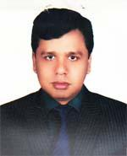 | DR. MD. FARUQ HOSSAIN  F/Name: Late Haji Md. Hanif Prodhan  M/Name: Late Haji Khadiza Begum  BM & DC Reg. No: 43952  NID: 6710615167415  Cell: 01717299893  Address: Life Care Diagnostic and General Hospital, 3/5 S.S Shah Road, Bandar, Narayangonj  Blood Group: B+
131 | Voter No  LM-4400130  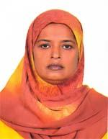 | DR. ROWSHAN ARA BEGUM  F/Name: Late Abdul Quddus Mollah  M/Name: Late Mrs. Amena Khatoon  BM & DC Reg. No: 16579  NID: 6725804350622  Cell: 01715015984  Address: 38/16 Allam Iqbal Road, Narayangonj  Blood Group: O+
132 | Voter No  LM-4400131 | DR. MD. RIASAT AZIM  F/Name: Md. Abdul Mannan Biswas  M/Name: Dr. Rowshan Ara Begum  BM & DC Reg. No: 63851  NID: 19882694810999969  Cell: 01717441392  Address: 38/16 (New) or 38/10/1 (Old) Allama Iqbal Road, Narayangonj  Blood Group: B+
133 | Voter No  LM-4400132  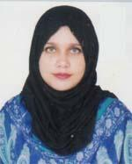 | DR. ARIFA AKTER  F/Name: Md. Abdur Rahim  M/Name: Salina Akhter  BM & DC Reg. No: 56241  NID: 2695044883780  Cell: 01671083526  Address: 12/1, S. K Road New Friends Market 5th Floor, Narayangonj  Blood Group: O+
134 | Voter No  LM-4400133  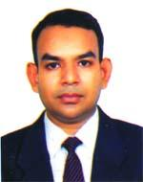 | DR. MD. SHAH ALAM SIKDER  F/Name: Md. Asak Sikder  M/Name: Most. Feroza Begum  BM & DC Reg. No: 24154  NID: 6720602246474  Cell: 01715127482  Address: 485, Wilson Road, Bandar, Narayangonj  Blood Group: AB+
135 | Voter No  LM-4400134  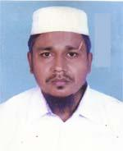 | DR. MOHAMMAD TOFAZZAL HOSSAIN  F/Name: Md. Obaidul Haque  M/Name: Jahanara Haque  BM & DC Reg. No: 29770  NID: 6715837387357  Cell: 01711132167  Address: New Advashd,Narayanganj  Blood Group: B+
136 | Voter No  LM-4400135  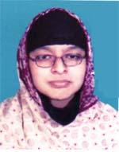 | DR. SAJIA AFRIN  F/Name: Md. Sahidul Islam  M/Name: Rozy Begum  BM & DC Reg. No: 52192  NID: 6725804366172  Cell: 01817523562  Address: 30, H.K Banergy Rd. Amlapara, Narayangonj  Blood Group: n_a
137 | Voter No  LM-4400136  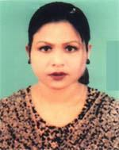 | DR. SHAHANA SULTANA  F/Name: Md. Ali Akkas  M/Name: Mrs. Hamida Ali  BM & DC Reg. No: 47336  NID: 6725818357749  Cell: 01768464026  Address: Godnail Baripara, Siddirgonj, Narayangonj  Blood Group: A+
138 | Voter No  LM-4400137  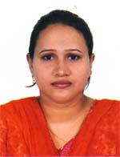 | DR. MARUFA AKTER  F/Name: Late Md. Mojibur Rahman  M/Name: Taslima Begum  BM & DC Reg. No: 43290  NID: 6720602253340  Cell: 01717563243  Address: 87/1, DP Road 2 No. Baburial, Narayangonj  Blood Group: B+
139 | Voter No  LM-4400138 | DR.KAZI JAHIRUL ISLAM  F/Name: Late Kazi Abul Basher  M/Name: Nurun Nahar Begum  BM & DC Reg. No: 44650  NID: 6720602253338  Cell: 01717563244  Address: 163 No. HM Sen Road, Bondor, Narayangonj  Blood Group: O+
140 | Voter No  LM-4400139 | DR. M. ABUL KALAM AZAD  F/Name: Md. Ali Hossain Gazi  M/Name: Mrs. Suvoja Begum  BM & DC Reg. No: 47052  NID: 6715825468672  Cell: 01913779766  Address: House 55, Road 6, Block B, Lane East Isdair, Zella Parishad, Fatullah, Narayangonj  Blood Group: AB+
141 | Voter No  LM-4400140 | DR. JAMIL HASSAN JEWEL  F/Name: Md. Nasir Uddin  M/Name: Rehena Akhter  BM & DC Reg. No: 42737  NID:  Cell: 01711074437  Address: Vill-Dhormogonj Paza Pur, Post-Enayetnagar, Thana-Fatullah, Dist-Narayangonj  Blood Group: A+
142 | Voter No  LM-4400141  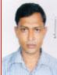 | DR. PRAKASH KUMAR SAHA  F/Name: Subol Chandraa Saha  M/Name: Basana Rani Saha  BM & DC Reg. No: A25229  NID:  Cell:  Address: 90, Pandu Lai  Market Kali Bazar  Narayanganj  Blood Group: B+
143 | Voter No  LM-4400142 | DR. ANAMIKA SAHA  F/Name: Engr. Rabindra Ranjan Saha  M/Name: Dr. Chinu Rani Roy  BM & DC Reg. No: 58059  NID: 2695434997742  Cell: 01674744527  Address: F # 1C, GTH Floor, Globe Nibash, 337-371, Outer Circular Road, Rajarbag, Dhaka-1217  Blood Group: A+
144 | Voter No  LM-4400143  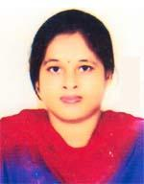 | DR. NIGAR SULTANA  F/Name: Late Alhaj Md. Nurul Islam  M/Name: Mrs. Shelina Islam  BM & DC Reg. No: 73052  NID: 19906725803000077  Cell: 01815686691  Address: Holding # 79/1, House # 148, Khanpur Main Road, Narayanganj Sadar, Narayangonj-1400  Blood Group: B+
145 | Voter No  LM-4400144  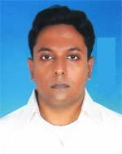 | DR. MIR MEFTAHUL HOSSAIN  F/Name: Alhaj Mir Mobarak Hossain  M/Name: Late Alhaj Mir Nazma Begum  BM & DC Reg. No: 58293  NID: 6725803905523  Cell: 01842736271  Address: Holding # 79/1, House # 148, Khanpur Main Road, Narayangonj Sadar, Narayangonj-14  Blood Group: O-
146 | Voter No  LM-4400145 | DR. SERATESABIHA ZARIN  F/Name: Md. Anwar Hossain  M/Name: Sajeda Momen  BM & DC Reg. No: A51742  NID: 6725804377956  Cell:  Address: 5, Allama Iqbal  Road, Narayanganj  Blood Group: A+
147 | Voter No  LM-4400146 | DR. A. K. M SULTAN AHMED  F/Name: Late Munshi Mohd. Nurul Islam  M/Name: Mrs. Aleya Khatun  BM & DC Reg. No: 18499  NID: 1923603851484  Cell: 01715191393  Address: New Adarsha Pharmacy, Alauddin Market, Paunchabati, Fatullah, Narayangonj  Blood Group: B+
148 | Voter No  LM-4400147  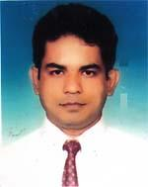 | DR. MOHAMMAD SHAHEEN MIAH  F/Name: Late Gias Uddin Ahmed  M/Name: Late Rahima Begum  BM & DC Reg. No: 31793  NID: 6725809038791  Cell: 01711900039  Address: 158, Sultan Gias Uddin Road, Muslim nagar, Narayangonj-1400  Blood Group: B+
149 | Voter No  LM-4400148  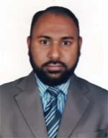 | DR. MOHAMMAD ABDUN NUR SAYAM  F/Name: Mohammad Abdul Mannan  M/Name: Mst. Rashida Khatun  BM & DC Reg. No: 38130  NID: 19786715879329688  Cell: 01712247666  Address: House No. 4, Road no. 1, Noorbag, Kutubpur, Fatullah, Narayanganj  Blood Group: O+
150 | Voter No  LM-4400149  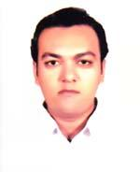 | DR. GOLAM MUSTAFA IMON  F/Name: Md. Nurul Alam  M/Name: Selina Begum  BM & DC Reg. No: 34807  NID: 6725809035062  Cell: 01711619215  Address: 295 New , 260-Old, B.K Road Netaiganj, Narayangonj  Blood Group: O+
151 | Voter No  LM-4400150  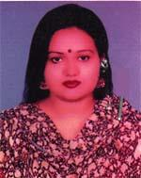 | DR. RAFIA MASUD  F/Name: Masudur Rahman Mollah  M/Name: Fatema Begum  BM & DC Reg. No: 52839  NID: 19852612980871692  Cell: 01675839775  Address: Matuail Konapara, Katerpur Demra, Dhaka  Blood Group: B+
152 | Voter No  LM-4400151  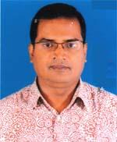 | DR. MOHAMMAD AULAD HOSSAIN  F/Name: Mohammad Afzal Islam  M/Name: Late Zarina Begum  BM & DC Reg. No: 32283  NID: 0113857475016  Cell: 01914664533  Address: House No. 55, Ward-1, Road-2, Enayetnagar, Fatullah, Narayangonj  Blood Group: O+
153 | Voter No  LM-4400152 | DR. GAZI MUHAMMAD SALAHUDDIN  F/Name: Muhammad Quamruzzaman  M/Name: Rawshon Ara Begum  BM & DC Reg. No: 37074  NID: 6715831451081  Cell: 01914159006  Address: Flat no 4C, Century majeda, 18 Sabbir Alam Khondoker Road, Mardair, Narayangonj  Blood Group: O+
154 | Voter No  LM-4400153  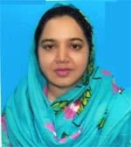 | DR.TAHMINA CHOWDHURY JHARNA  F/Name: Tazuddin Chowdhury  M/Name: Razia Sultana  BM & DC Reg. No: 56397  NID: 6725818337873  Cell: 01924969704  Address: Vill-Anayetnagar, Post-L.N Mills, P.s-Siddirgonj, Dist-Narayangonj  Blood Group: O+
155 | Voter No  LM-4400154  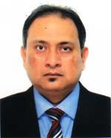 | DR. MD. KHALED BIN RASUL  F/Name: Late Md. Abdur Rasul  M/Name: Lutfun Nessa  BM & DC Reg. No: 22804  NID: 6715863563708  Cell: 01926668154  Address: 233/6, Bhasha Sainik Road, Chashara C/a Plot No. 21, Flat No. 5/B, Narayanganj-1400  Blood Group: O+
156 | Voter No  LM-4400155 | DR. CHOWDHURY MD. IQBAL BAHAR  F/Name: Dr. Habibur Rahman Chowdhury  M/Name: Mrs. Jebunnessa Chowdhury  BM & DC Reg. No: 33313  NID: 6715837403556  Cell: 01777111111  Address: 300 Bed Hospital, Khanpur, Narayanganj  Blood Group: A+
157 | Voter No  LM-4400156  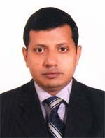 | DR. BIDHAN CHANDRA PODDER  F/Name: Late Naliai Kumar Podder  M/Name: Amalu Rani Podder  BM & DC Reg. No: 30008  NID: 0695112191922  Cell: 01712584212  Address: Doctors Quarter, 300 Bedded Hospital, Narayanganj  Blood Group: B+
158 | Voter No  LM-4400157  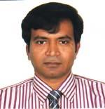 | DR. SHEIKH FORHAD  F/Name: Sheikh Motiur Rahman  M/Name: Fatima Khanam  BM & DC Reg. No: 34754  NID: 6725804351482  Cell: 01819482481  Address: 95, College Road, Narayanganj-1400  Blood Group: A+
159 | Voter No  LM-4400158  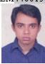 | DR. ANIRUDHAW BHATTACHRJEE  F/Name: Late Ashim Kumar Bhattachrjee  M/Name: Jharana Bhattacharjee  BM & DC Reg. No: A 49583  NID:  Cell:  Address: C/o. Dr. Bidhan Chandra Podder  Junior Consultant, Shishu Dept  300 Beded Hospital, Khanpur,  Narayanganj.  Blood Group:
160 | Voter No  LM-4400159  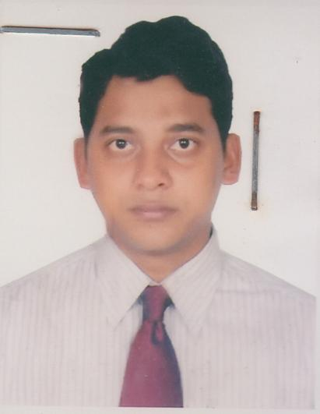 | DR. MOHAMMAD SHAMSUDDOHA SARKAR SHANCHAY  F/Name: Mohammad Rafique Ullah  M/Name: Mrs. Shamsun Nahar  BM & DC Reg. No: 40559  NID: 6715837434303  Cell: 01911746750  Address: RP, Medicine  300 Beded Hospital, Narayangonj Sadar,  Narayangonj  Blood Group: O+
161 | Voter No  LM-4400160  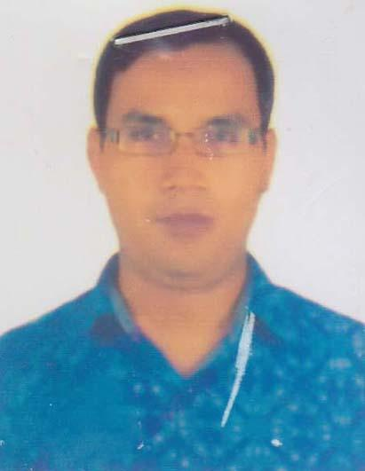 | DR. MD. AMINUL ISLAM  F/Name: Md. Quasim Uddin  M/Name: Mrs. Amena Khatun  BM & DC Reg. No: 33479  NID: 7328501179051  Cell: 01712666634  Address: Dept Of Pediatric, 300 bed Hospital, Narayanganj.  Blood Group: O+
162 | Voter No  LM-4400161  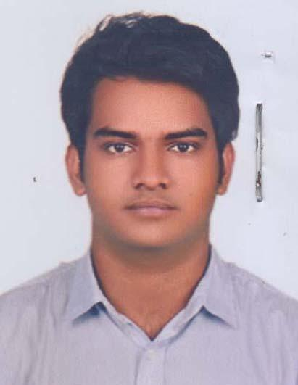 | DR. GULAM DASTAGEER PRINCE  F/Name: Md. Gulam Mostafa  M/Name: Tahmina Mostafa Ratna  BM & DC Reg. No: 87332  NID: 19946710226000107  Cell: 01670974760  Address: 65, SJ Jahanara Imam Sarani Elephont Road, Dhaka-1205.  Blood Group: A+
163 | Voter No  LM-4400162  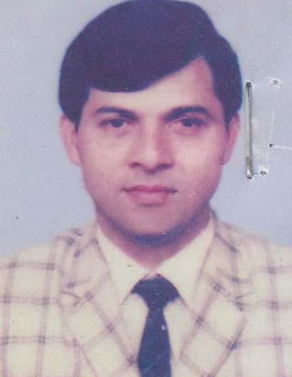 | DR. MD. ZAKARIA  F/Name: Late Nayeb Ali Master  M/Name: Late Rahima Begum  BM & DC Reg. No: 6862  NID: 2617680163100  Cell: 01720127494  Address: Cure Consultation & Diagnostic Signboard 5201, South Matuail Demra, Dhaka. Consultant, Orthopedics, Unique Diagnostic Centre, Khanpur,  Blood Group: O+
164 | Voter No  LM-4400163  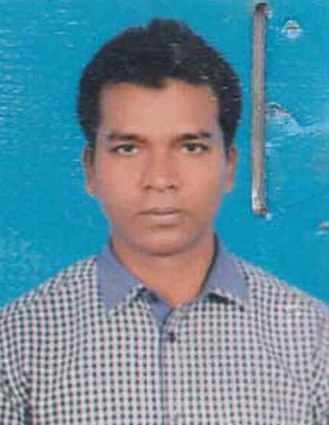 | DR. MD. ABUL KALAM AZAD  F/Name: Jamal Uddin Ahmed  M/Name: Alefa Begum  BM & DC Reg. No: 37485  NID: 9410821607451  Cell: 01712222182  Address: Consultant Surgery, 300 Beded Hospital, Narayongonj.  Blood Group: A+
165 | Voter No  LM-4400164  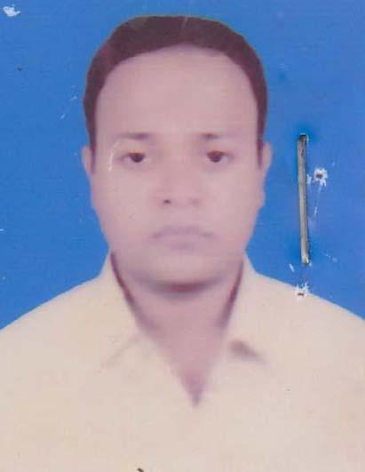 | DR.FAISAL AHMED  F/Name: Md. Altaf Hossain  M/Name: Mrs. Feroza Begum  BM & DC Reg. No: 44335  NID: 1982715837000356  Cell: 01910414341  Address: 8th Floor (South) Mollah Tower Amlapara, Narayangonj.  Blood Group: O+
166 | Voter No  LM-4400165  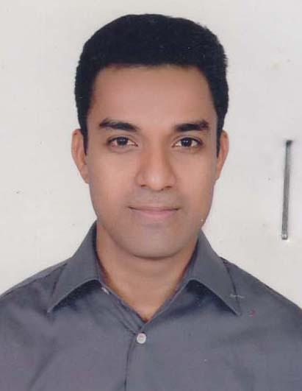 | DR. MOHAMMAD MAHBUB HOSSAIN  F/Name: Late. Mohammad Sohrab Hossain  M/Name: Delowara Begum  BM & DC Reg. No: 33445  NID:  Cell: 01818884636  Address: House: 34-36, Road: 8 Block-E, Nilceton gulshan-1, consultant, Medicine, 300 Bedded Hospital, N.Ganj  Blood Group: O-
167 | Voter No  LM-4400166  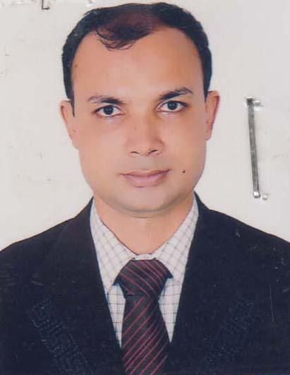 | DR. MOHAMMAD SHAHADAT HOSSAIN  F/Name: Mohammad Nurul Haque  M/Name: Shahida Akter  BM & DC Reg. No: 42037  NID: 6716855819301  Cell: 01718263338  Address: Upazilla Health Complex, Sadar, Narayangonj.  Blood Group: O+
168 | Voter No  LM-4400167  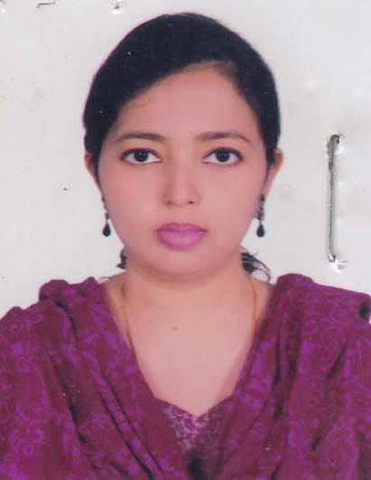 | DR. SHAMIMUN NAHAR  F/Name: Abdul Motalib  M/Name: Shamsun Nahar  BM & DC Reg. No: 64077  NID: 9196203131894  Cell: 01737706193  Address: Upazilla Health Complex, Sadar, Narayangonj.  Blood Group: O+
169 | Voter No  LM-4400168  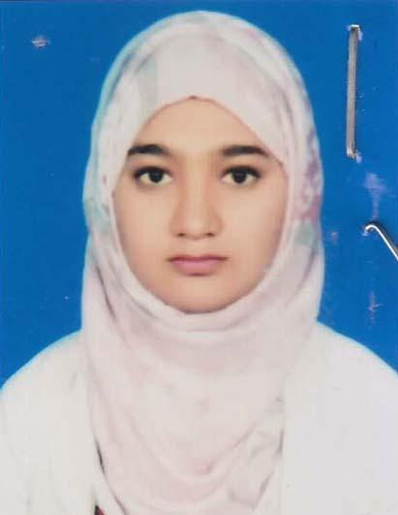 | DR. SABERA AFRIN DINA  F/Name: Md. Anarul Islam Dulal  M/Name: Jesmin Akhter  BM & DC Reg. No: 87070  NID: 19946715879000828  Cell: 01774430588  Address: Nayamati, Kutubpur, Narayanganj Sadar, Naraynganj.  Blood Group: AB+
170 | Voter No  LM-4400169  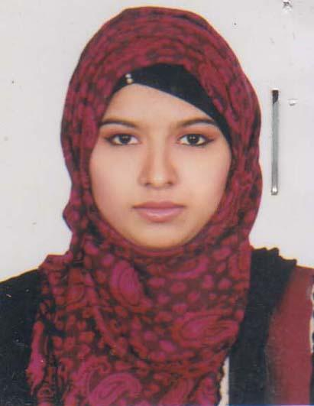 | DR. TASUNA TASFIN BONY  F/Name: Dr. Md. Altaf Hossain  M/Name: Dr. Halima Akhter  BM & DC Reg. No: 69968  NID: 6725803907148  Cell: 01611150040  Address: 19/A, Shaheed Sabbir Alom Khondokar Road, Masdair, Narayanganj.  Blood Group: B+
171 | Voter No  LM-4400170  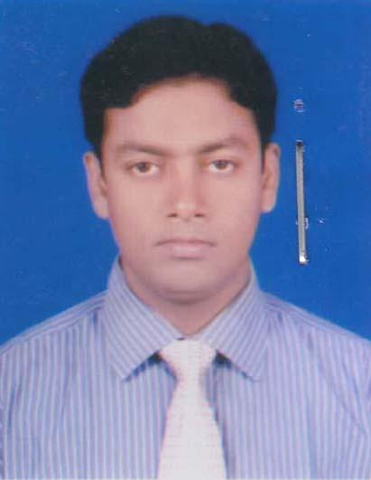 | DR. S.M. IFTEKHAR UDDIN SAGAR  F/Name: A.k.m. Sharif Uddin  M/Name: Kulsuma Begum  BM & DC Reg. No: 49094  NID: 9196203120891  Cell: 01711075931  Address: Sajeda Monjil (3rd Floor), Jarzis Garden, Masdair Gorosthan, Narayanganj  Blood Group: B+
172 | Voter No  LM-4400171  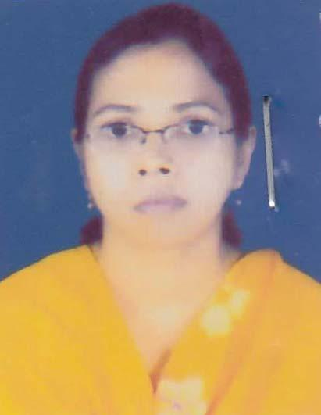 | DR. RUBINA BARI  F/Name: Sk. Abdul Bari  M/Name: Jarina Begum  BM & DC Reg. No: 33615  NID: 0113857475015  Cell: 01711363770  Address: 300 beded Hospital, Narayangonj.  Blood Group: AB+
173 | Voter No  LM-4400172  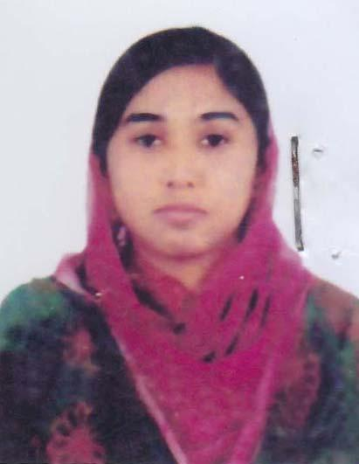 | DR. JANNATUL NAYEM  F/Name: Jamil Hossain  M/Name: Safia Begum  BM & DC Reg. No: 60178  NID:  Cell: 01766741838  Address: 300 Bedded Hospital, Narayangonj.  Blood Group: A+
174 | Voter No  LM-4400173  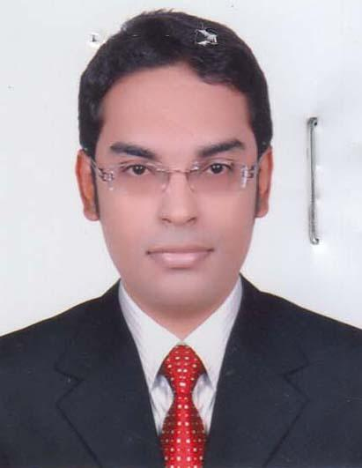 | DR. SHAFAYET AREFIN  F/Name: Belayet Hossain Bhuiyan  M/Name: Akhter Nahar  BM & DC Reg. No: 65762  NID: 6725304702155  Cell: 01715149743  Address: House No: 02, Advocates Road, Adarsha Chashara, Chandmari, Narayangonj-1400.  Blood Group: B+
175 | Voter No  LM-4400174  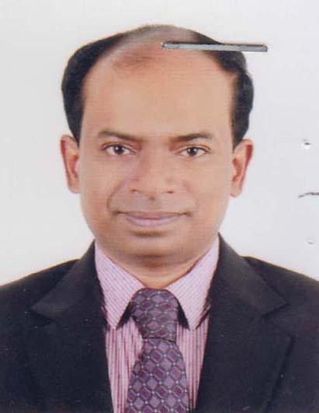 | DR. A.K.M. MEHEDI HASAN  F/Name: Mohammad Chand Mia  M/Name: Jahanara Begum  BM & DC Reg. No: 38337  NID: 2696654287104  Cell: 01712274070  Address: 287/4, Ambagan, Nayatola, Moghbazar, Dhaka-1217.  Blood Group: O+
176 | Voter No  LM-4400175  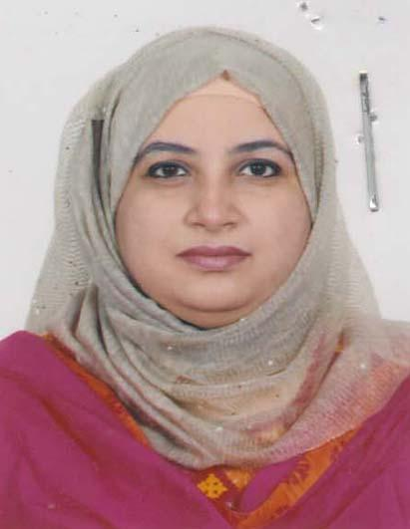 | DR. UMME RUMANA JAHAN  F/Name: Md. Moniruzzaman  M/Name: Jahanara Begum  BM & DC Reg. No: 37192  NID: 6725803909095  Cell: 01711130505  Address: 63/1, Nawab Solimullah Road, Missionpara, Narayanganj.  Blood Group: B+
177 | Voter No  LM-4400176  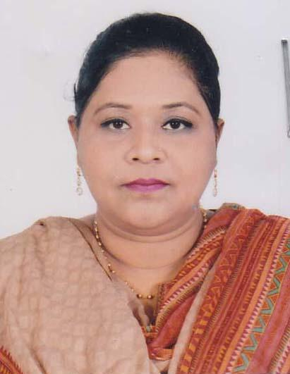 | DR. FARJANA YASMIN  F/Name: Gias Uddin Ahmed  M/Name: Yeasmin Ahmed  BM & DC Reg. No: 66273  NID:  Cell: 01677397655  Address: 20B, DAS, Road, Dailpotti, Narayangonj.  Blood Group: A+
178 | Voter No  LM-4400177  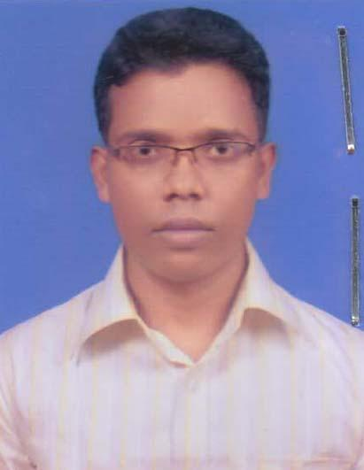 | DR. SHASHANKO SHEKHOR MONDAL  F/Name: Nirapada Mondal  M/Name: Usha Rani Mondal  BM & DC Reg. No: 68143  NID: 2699501912184  Cell: 01716594479  Address: Bank Coloni, Khanpur, Narayangonj.  Blood Group: A+
179 | Voter No  LM-4400178  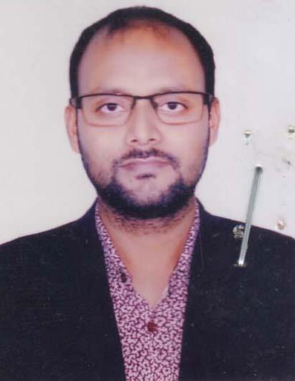 | DR. AL- WAZEDUR RAHMAN  F/Name: Md. Mijanur Rahman Miah  M/Name: Hosne Ara Rahman  BM & DC Reg. No: 53718  NID: 6725812459291  Cell: 01673657945  Address: 302/D, Mouchak(Matin sarak), Mizmizi-1430, Siddirgonj, Narayangonj City Corporation.  Blood Group: B+
180 | Voter No  LM-4400179  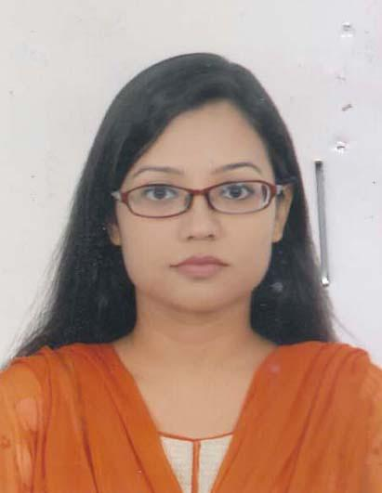 | DR. LUTFUN NAHAR  F/Name: Md. Lutfor Rahman Chowdhury  M/Name: Jahanara Begum  BM & DC Reg. No: 63112  NID: 19876715837422482  Cell: 01917400969  Address: House No: 15, Road No: 2, Block: B, Ajmeribag, Khapur, Fatullah, Narayangonj.  Blood Group: A+
181 | Voter No  LM-4400180  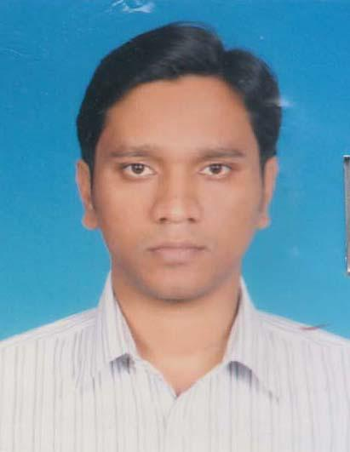 | DR. DEVRAJ MALAKAR  F/Name: Sukumar Malakar  M/Name: Anjoly Rani Malakar  BM & DC Reg. No: 39771  NID: 6725803908667  Cell: 01711120810  Address: 6, Nawab Salimullah Road, Narayanganj.  Blood Group: O+
182 | Voter No  LM-4400181  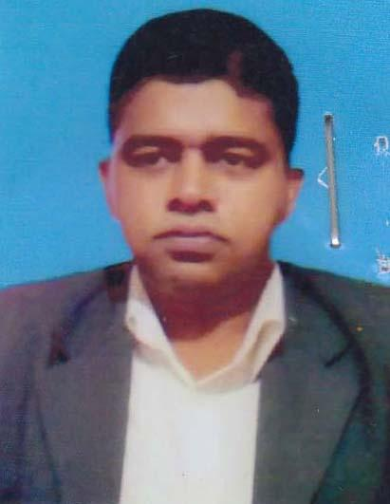 | DR. MOHAMMAD ARMAN FERDOSSE  F/Name: Late Sahabuddin Ahmed  M/Name: Amjadi Begum  BM & DC Reg. No: 58199  NID:  Cell: 01847233250  Address: 118 No. Nabiganj Road, Bandar, Narayanganj.  Blood Group: AB+
183 | Voter No  LM-4400182  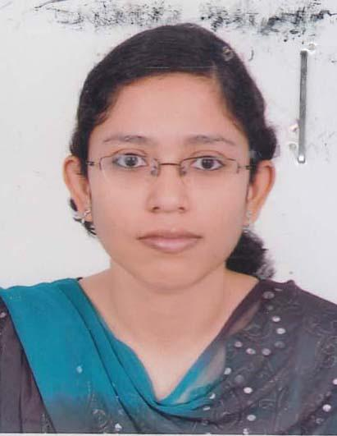 | DR. SANCHITA PODDER  F/Name: Shayan Kumer Podder  M/Name: Rita Podder  BM & DC Reg. No: 59295  NID: 19880695112193384  Cell: 01710592870  Address: 55/16 S.M Maleh Road, Tanbazar, Narayangonj.  Blood Group: B+
184 | Voter No  LM-4400183  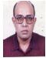 | DR. RANJIT RANJAN ROY  F/Name: Late.begati Ranjan Roy  M/Name: Mrs.puspa Roy  BM & DC Reg. No: A­13187  NID: 8209167033  Cell:  Address: 236 New Elephant Road, Flat#6/c, Dhaka.  Blood Group: O+
185 | Voter No  LM-4400184  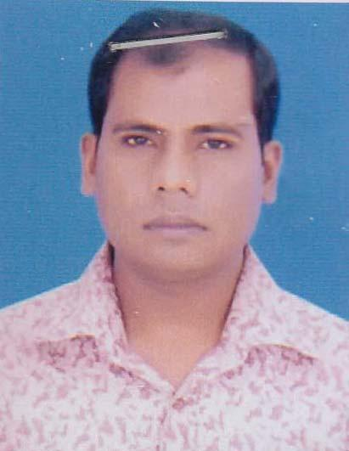 | DR. MOHAMMAD ABDUL MALEK  F/Name: Mohammad Mojibur Rahman  M/Name: Sayeda Rasheda Begum  BM & DC Reg. No: 35320  NID: 7313869617  Cell: 01816419203  Address: Asst. Registrar (Medicine), 300 Bedded Hospital, Narayanganj.  Blood Group: B+
186 | Voter No  LM-4400185  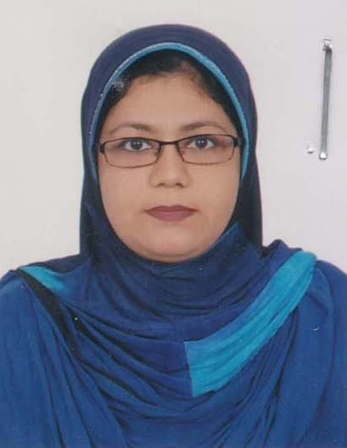 | DR. MASUDA SULTANA  F/Name: Md. Mozammel Hoque  M/Name: Mrs. Showkat Ara Begum  BM & DC Reg. No: 31164  NID: 2691649120997  Cell: 01713451898  Address: Flat No: CD-8, 13 Sharkar, West Dhanmadi, Dhaka/Consultant Gynae 300 Bed Hospital-N.Gonj.  Blood Group: B+
187 | Voter No  LM-4400186  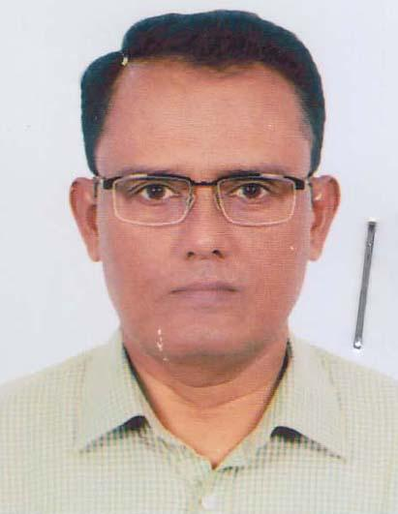 | DR. A.N.M. NURUL HAQUE BHUIYAN  F/Name: Bashir Uddin Ahmed  M/Name: Most. Foijun Nesa  BM & DC Reg. No: 24190  NID: 19686720409814242  Cell: 01911147150  Address: 2/2, Sher- e Bangla Road, Kasfa Tower, Masdair, Narayanganj.  Blood Group: A+
188 | Voter No  LM-4400187  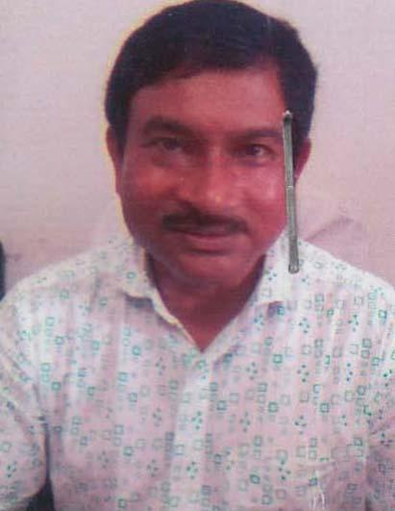 | DR. MD. ASADUZZAMAN  F/Name: Late Md. Abdus Samad  M/Name: Late Salma Samad  BM & DC Reg. No: 16165  NID: 4614647453  Cell: 01731152711  Address: General Hospital Naryanganj.  Blood Group: A+
189 | Voter No  LM-4400188  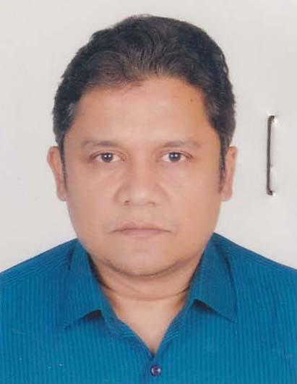 | DR. ABU SAYEED MD. FERUZ MUSTAFA  F/Name: Dr. Md. Golam Mustafa  M/Name: Ferdous Ara Begum  BM & DC Reg. No: 29667  NID: 2896655331625  Cell: 01819489065  Address: 404, Modhubag, Mogbazar, Dhaka/ Heneual Hospital, N.gonj.  Blood Group: O+
190 | Voter No  LM-4400189  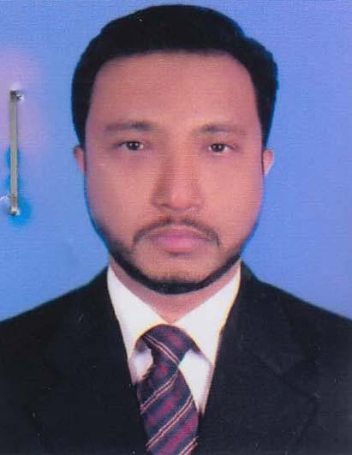 | DR. A.B.M ZAHIRUL QUDER BHUIYAN  F/Name: Md. Abdul Quder Bhuiyan  M/Name: Late Jahanara Begum  BM & DC Reg. No: 39321  NID: 2610457061050  Cell: 01719110677  Address: F1-15- A1, Rupayan Town Fatulla, Narayanganj.  Blood Group: O+
191 | Voter No  LM-4400190  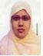 | DR. SHILPY AKTER  F/Name: Mohammad Ahasan Uddin  M/Name: Sufia Khatun  BM & DC Reg. No: 41628  NID:  Cell:  Address: Vill-Delpara, Post-­Kutubpur  Thana­Fatulla, Dist: Narayangonj.  Blood Group: O+
192 | Voter No  LM-4400191  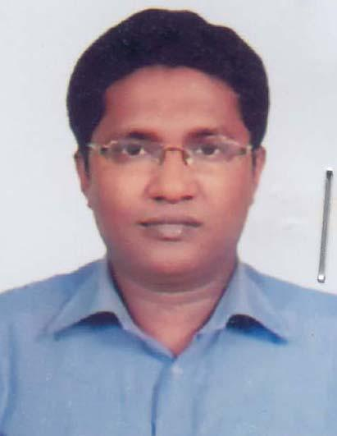 | DR. MD. SAKHAWAT HOSSAIN  F/Name: Md. Abul Hossain  M/Name: Kursia Begum  BM & DC Reg. No: 48222  NID:  Cell: 01913499301  Address: 128/1, Shahsuja Road, Jallar Para, Narayanganj.  Blood Group: O+
193 | Voter No  LM-4400192  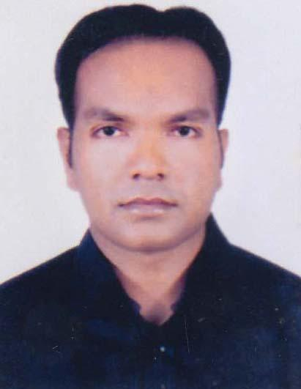 | DR. MD. ABDUL QUIYUM  F/Name: Noor Mohammad Sarker  M/Name: Josna Akter  BM & DC Reg. No: 59368  NID: 19880695114206607  Cell: 01764688486  Address: 612, Block: A, BSMMU, Shahbag, Dhaka.  Blood Group: A+
194 | Voter No  LM-4400193  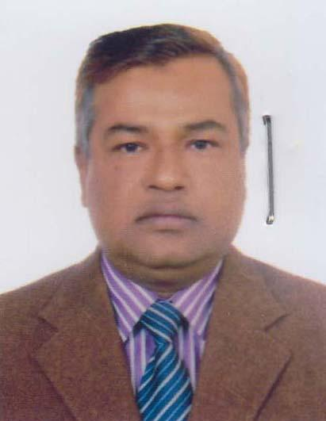 | PROF. DR. FARUK AHAMMAD  F/Name: Late Md. Nurul Islam  M/Name: Mrs. Regia Begum  BM & DC Reg. No: 23121  NID: 2370464170  Cell: 01817011894  Address: Consultant Medicine , Labaid, Narayanganj.  Blood Group: B+
195 | Voter No  LM-4400194  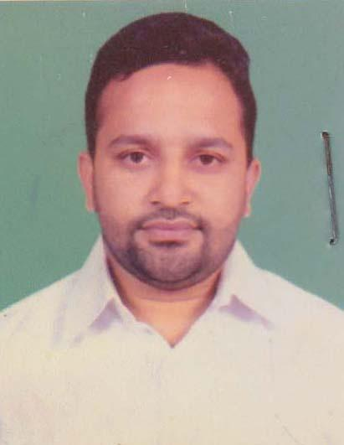 | DR. MD. TAJUL ISLAM MUNNA  F/Name: Md. Sirajul Hoque  M/Name: Masuda Begum  BM & DC Reg. No: 70218  NID: 19906715863000733  Cell: 01674066190  Address: Vill: Faraha kandha P.O: Naryanganj, P.S: Fatullah, Dist: Narayanganj.  Blood Group: O+
196 | Voter No  LM-4400195  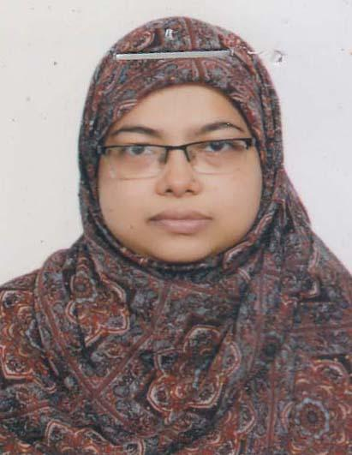 | DR. BEGUM MORIOM ZAMILA  F/Name: S.m. Shafiqur Rahman  M/Name: Farida Begum  BM & DC Reg. No: 46299  NID: 19836725802900991  Cell: 01710991647  Address: House No: 8, Road: 2, Block: B, Lane: 1, West Masdair, Fatulla, Narayanganj.  Blood Group: A+
197 | Voter No  LM-4400196  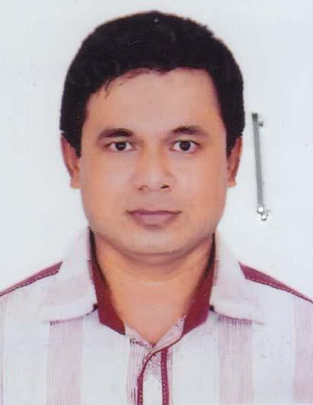 | DR. MD. ASHRAFUZAMAN  F/Name: Md. Tauhidul Haque  M/Name: Shirina Begum  BM & DC Reg. No: 30683  NID: 2691648052548  Cell: 01712027453  Address: Asst. Registrar, Paediatrics, 300 Beded Hospital, Narayanganj.  Blood Group: O+
198 | Voter No  LM-4400197  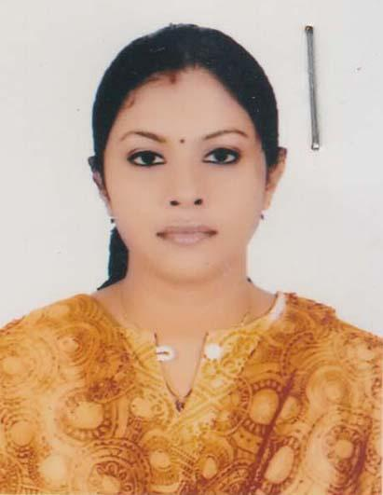 | DR. DIPANNITA DHAR  F/Name: Late Mrinal Kanti Dhar  M/Name: Anima Dhar  BM & DC Reg. No: 51199  NID: 19860695112194082  Cell: 01752411022  Address: Doctors Quarter (Belly) 300 Bed Hospital, Khanpur, Narayanganj.  Blood Group: B+
199 | Voter No  LM-4400198  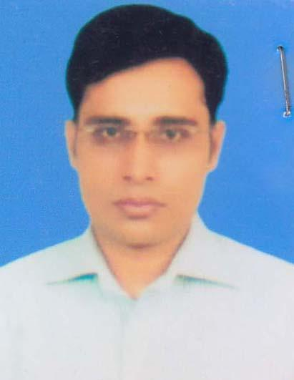 | DR. FARAZI MOHAMMAD MAHBUBUL ALAM MANZU  F/Name: Md. Abubakar Shiddique  M/Name: Mrs. Rahima Khaton  BM & DC Reg. No: 34439  NID: 8916785506978  Cell: 01682512143  Address: 300 Beded Hospital, Narayanganj.  Blood Group: A+
200 | Voter No  LM-4400199  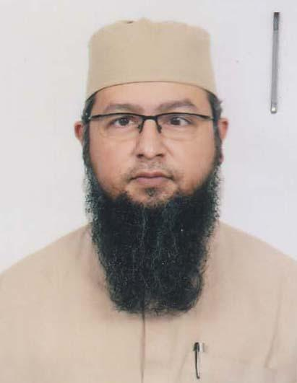 | DR. NUR FAYSAL AHMED  F/Name: Nur Mohammad  M/Name: Akikul Bahar  BM & DC Reg. No: 36911  NID: 6725801286725  Cell: 01718748034  Address: 6/7, BegunBagicha, Topkhana Road, Dhaka, Flat Dom-NNO E( Dorado(B-8).  Blood Group: A+
201 | Voter No  LM-4400200  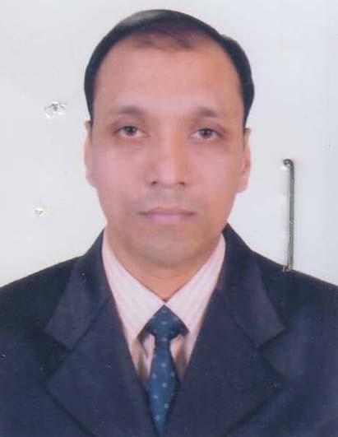 | DR. ALAK KUMAR SAHA  F/Name: Amal Chandra Saha  M/Name: Lata Rani Saha  BM & DC Reg. No: 36330  NID:  Cell: 01711066860  Address: 395, D.P. Road, New Palpara, Narayanganj.  Blood Group: O+
202 | Voter No  LM-4400201  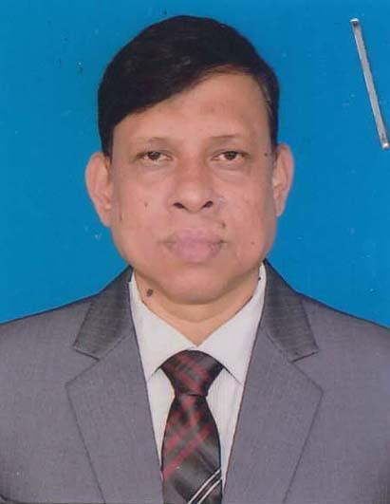 | DR. MAMUN RASHID BHUIYA  F/Name: Late A.b.md. Waliullah Bhuiya  M/Name: Late Maleka Akhter Khanam  BM & DC Reg. No: 15397  NID: 2612935354006  Cell: 01711858542  Address: Senior consultant (Ortho -Surgery), 300 Bedded Hospital, Narayangonj.  Blood Group: O+
203 | Voter No  LM-4400202  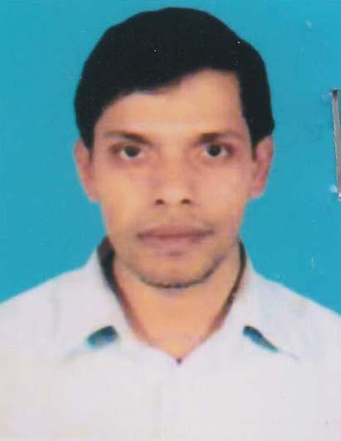 | DR. KUMER TANSHEN  F/Name: Ashit Kumar Dey  M/Name: Bishakha Rani Chowdhury  BM & DC Reg. No: 38790  NID: 19796725803709717  Cell: 01720286166  Address: 43, Uttor Chashara , Thana: Fatullal, P.O & Dist: Narayangonj.  Blood Group: A+
204 | Voter No  LM-4400203 | DR. MOHAMMAD NASIRUL ISLAM  F/Name: Late Abdul Gafur  M/Name: Naziba Begum  BM & DC Reg. No: A­26941  NID: 2693625856165  Cell:  Address: Consultant Medicine Mediplus Diagnostic Center, President Road, Narayangonj.  Blood Group: A+
205 | Voter No  LM-4400204  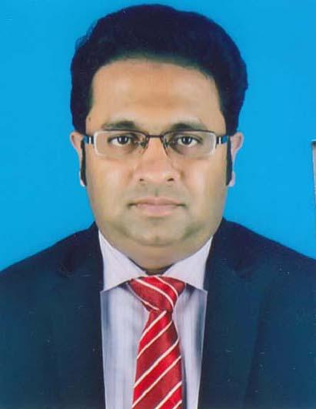 | DR. TANVIR AHMED CHOWDHURY  F/Name: Late. Sharfuddin Ahmed  M/Name: Rokeya Begum  BM & DC Reg. No: 33461  NID: 2696829653355  Cell: 01712882902  Address: 44/1, Dhaka-1214/UHIPO, North Upazila Health complex, Sonargao, N.ganj.  Blood Group: A+
206 | Voter No  LM-4400205  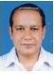 | DR. PALAK KUMAR MOHANTA  F/Name: Sree Prafullah Kumar Mohanta  M/Name: Mrs Chafa Rani Mohanta  BM & DC Reg. No: 14773  NID: 2694266781569  Cell:  Address: Consultant Skin&VD Dept.  300 Beded Hospital, Narayanganj.  Blood Group: B+
207 | Voter No  LM-4400206  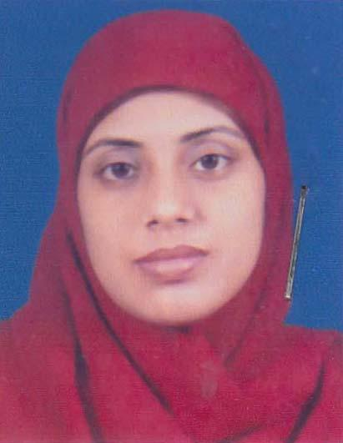 | DR. AFROZA AKTER POLY  F/Name: Abdul Mannan Bhuiyan  M/Name: Mrs. Rozina Mannan  BM & DC Reg. No: 47448  NID: 6715831515503  Cell: 01816503993  Address: H/N: 57, Road:2, Block: C, Ward: 9, North Masdair, Fatullah, Narayangonj.  Blood Group: AB+
208 | Voter No  LM-4400207  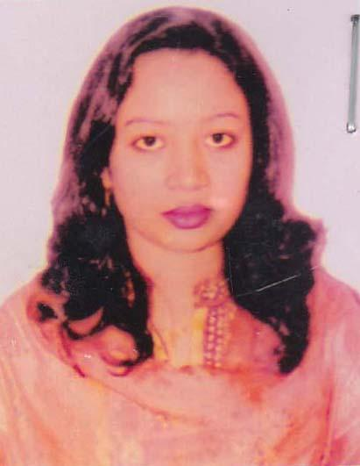 | DR. YASMIN AKTER  F/Name: Md. Edrish Ali  M/Name: Mrs. Roksana Ali  BM & DC Reg. No: 47329  NID: 1900403708  Cell: 01716372040  Address: 143, B.B. Road, Naryanganj.  Blood Group: B+
209 | Voter No  LM-4400208  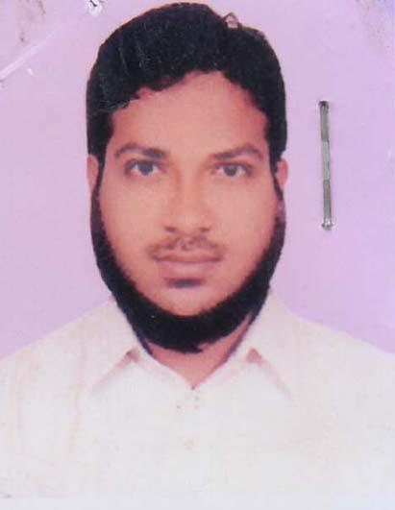 | DR. KAMRUL HASAN SAJIB  F/Name: Md. Safiqul Islam  M/Name: Saleha Begum  BM & DC Reg. No: 56721  NID:  Cell: 01674471860  Address: Araihazar General Hospital, Araihazar Narayanganj.  Blood Group: B+

